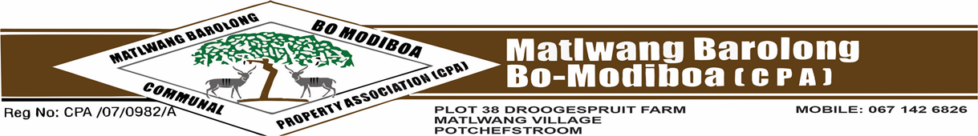
OFFICE OF THE SECRETARIAT AND COMMUNICATIONS
Enquiry: Mr. MN Kganticoe Cell no: 067 6941 926
email: mokgethikganticoe5@gmail.com
: Ms. JM Seboko Cell no: 076 6469 754
email: jeannyseb6@gmail.com

APPLICATION FOR RESIDENTIAL FORM

The form must be accompanied by the following documents.
- Letter of application
- Certified ID copy
- Proof of current address
RE: Application form seeks to verify and certify that the applicant complies with all rules and regulations set out in the Constitution (clause 7.1) & Restitution Act 22 of 1994(sec 2(1) (a-e).
PERSONAL DETAILS

Full Names of the applicant: ___________________________________
Surname___________________________
ID No__________________________
Gender: ___________________________
Marital Status: __________________________
How many dependencies: __________________________
Contact No: __________________________ Email: _______________________

Reasons for Application (tick below)
Residential Business Other

If other state: _________________________________________________
VERIFICATION STATUS (if applicable)

Names of ODI: ___________________________________
Surname of ODI: ___________________________
Relationship to ODI: __________________________
Name of Kgoro: ___________________________
Full Names & Surname of Kgoro Rep: __________________________
Contact No: __________________________
Signature of Kgoro Rep: __________________________
AFFIRMATION/DECLARATION

I____________________________________ declare that I fully understand, accept, and adhere with the terms and conditions outlined here in this application.
(NB: The office gives an applicant 3 months to occupy the site/stand failure to do so the site/stand will be allocated to another applicant).
Applicant’s signature: Date:
____________________________ ______________________
Full Names and Surname of Verification Rep:
___________________________________________

Signature: Date:
_______________________________ ______________________

FOR OFFICE USE ONLY

Date Received: _______________________
Received by: __________________________
Outcome of the Application: Approved Declined

APPROVER

Signature: Chairperson: KV Ratikoane
Chairperson’s stamp

